| Test 1 - Version D | |
| --- | --- |
| Course Information: Phys 2A | Your Name: |

### Equations Provided

***d*** = ***v***o*t* + (1/2)***a****t*2 ***v*** = ***v***o + ***a****t*  ***F***net = *m****a*** ***F***g = *m***g** *F*fr ≤ s*N*  *F*fr = k*N* Use *g* = 10 m/s2

The following trig values may prove helpful: sin(30o) = 0.5; cos(30o) = 0.86; sin(45o) = 0.7; cos(45o) = 0.7

### Multiple-Choice Questions

1. I throw a ball upwards. Which of the following is a true statement?
2. At the top of its climb, its velocity will be 9.8 m/s2
3. At the top of its climb, its acceleration will go to 0.
4. At the top of its climb, its velocity will go to 0.
5. Both B and C.
6. A truck is traveling east through mud that is slowing down its speed. With west defined as negative, which of the following is correct?
7. Both its velocity and acceleration are negative.
8. Both its velocity and acceleration are positive.
9. Its velocity is positive but its acceleration is negative.
10. Its velocity is negative but its acceleration is positive.
11. Both its velocity and acceleration are 0, since both properties are vectors.
12. An object accelerates whenever it is:
13. Falling
14. Moving
15. Changing speed
16. Changing direction
17. Changing speed or direction
18. A point is located in a polar coordinate system by the coordinates *r* = 7.4 m and θ = 28°. The *y*-coordinate is closest to the following.
19. 6.39
20. 3.47
21. 4.87
22. 9.22
23. 7.40
24. A person walks 33.0° north of east for 3.20 km. How far due north and how far due east would she have to walk to arrive at the same location?
25. 1.74 km north and 2.68 km east
26. 2.31 km north and 2.31 km east
27. 3.21 km north and 1.58 km east
28. 2.66 km north and 1.72 km east
29. 1.32 km north and 4.63 km east
30. Calculate the *x*-component (in m) of a vector with magnitude 28.0 m and direction 42.0°.
31. 19.8 m
32. 17.1 m
33. 20.8 m
34. 17.5 m
35. 18.7 m
36. The graph of velocity versus time for an object moving along the *x*-axis is shown below. What is the average acceleration from time *t* = 3 seconds to *t* = 5 seconds? (5 pts)

|  |  |
| --- | --- |
| 1. 0 2. –0.25 m/s2 3. +4 m/s2 4. –4 m/s2 5. +0.25 m/s2 |  |

1. 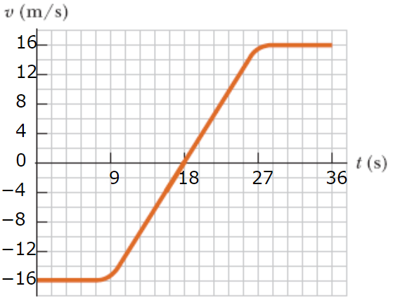The graph to the right plots velocity vs. time for an object moving along a straight path. What is the average acceleration of the object from 0 s to 9.00 s?
2. 1.78 m/s2
3. 0 m/s2
4. 0.9 m/s2
5. –1.78 m/s2
6. –0.9 m/s2
7. Referring to the same plot in the previous question, what is the instantaneous acceleration at *t* = 18 seconds?
8. 1.78 m/s2
9. 0 m/s2
10. 0.9 m/s2
11. –1.78 m/s2
12. –0.9 m/s2
13. The (1/2) ***a***t2 term in the displacement equation of motion measures
14. The distance an object travels while traveling at constant velocity
15. The square of the displacement traveled by the object due to its acceleration
16. The square of the distance traveled by the object due to its acceleration
17. The additional displacement traveled by an object due to its acceleration
18. Determinism states that …
19. … effects can be determined completely if one knows all there is about the causes.
20. … an algebra is composed of entities and the operations on those entities.
21. … the arrow on top of a variable indicates it is a vector, and that the arrow cannot be removed unless direction is inserted into an equation.
22. … studying intensely in physical science classes (such as physics and chemistry) does not guarantee top performance on an exam.
23. … classical systems are inherently probabilistic in nature and that it is pointless to talk about the exact motion of a system.
24. Speed and velocity
25. Are the same thing
26. Are similar, but speed is a scalar and velocity is a vector.
27. Are similar, but speed is a vector and velocity is a scalar.
28. Have no relationship to each other.
29. You throw a ball vertically upward, and as it leaves your hand, its speed is 37.0 m/s. How long (in s) does the ball take to return to the level where it left your hand after it reaches its highest point?
30. 1.38 seconds
31. 2.28 seconds
32. 3.78 seconds
33. 4.38 seconds
34. 5.18 seconds
35. You throw a ball vertically upward, and as it leaves your hand, its speed is 37.0 m/s. Assume that the upward direction is positive and the downward direction is negative. What is the ball's velocity (in m/s) when it returns to the level where it left your hand? (Indicate the direction with the sign of your answer.)
36. 37 m/s
37. 3 m/s
38. –37 m/s
39. 74 m/s
40. –74 m/s
41. A small mailbag is released from a helicopter that is descending steadily at 2.79 m/s. After 4.00 s, what is the speed of the mailbag?
42. 32 m/s
43. 42 m/s
44. 22 m/s
45. 12 m/s
46. 52 m/s
47. An object moves with constant acceleration 4.80 m/s2 and over a time interval reaches a final velocity of 12.4 m/s. If its initial velocity is −6.20 m/s, what is its displacement during this interval?
48. –20 meters
49. 20 meters
50. 10 meters
51. 12 meters
52. –12 meters

| Test 1 - Version D | |
| --- | --- |
| Course Information: Phys 2A | Your Name: |

The following trig values may prove helpful: sin(30o) = 0.5; cos(30o) = 0.86; sin(45o) = 0.7; cos(45o) = 0.7

### Free Responses

1. Pictured are three vectors. Using either the head-to-tail or parallelogram method, draw the resultant vector   
   **R** = **B** – **C** – **A** (note the subtraction symbols). Draw *neatly*.

|  |  |
| --- | --- |
|  |  |

1. Using the component method, perform the summation **R** = **D** – **C**. (Note the negative sign; this is vector subtraction.) Be sure to find the length of **R** and its direction. (Note: If you don’t have a calculator that’s fine. You can leave answers as is as long as the only step remaining is to calculate a numerical value.)



    
    
    